SEMRS Users Guide

Based on Version 1.0

# Hood College Senior Project 2012

### Ryan Kane & Ricky Orndorff

Table of Contents

Hood College Senior Project 2012 1

Ryan Kane & Ricky Orndorff 1

Getting Started 3

Getting to the Login Page 3

Logging In 3

Changing Passwords 4

Main Screen & Navigation 5

Physician 5

Receptionist 6

Adding Visit Information 8

Pharmacist 9

Adding a New Patient 9

Viewing a Patient 10

Changing a Patient’s Photo 11

Viewing Appointments 11

# Getting Started

## Getting to the Login Page

In your browsers address bar you will need to enter the location of your SEMRS installation. For most users this address will consist of the name of your server followed by a forward leaning slash, "semrs" and another forward leaning slash. This should look like this:

https://MyServerName/semrs/

Be sure to check with your Administrator, as the location of your SEMRS installation may be different. As an example the SEMRS location on the developer’s machine is located at:

https://localhost/semrs/

Once you have entered the correct address, you should be presented with the login screen:

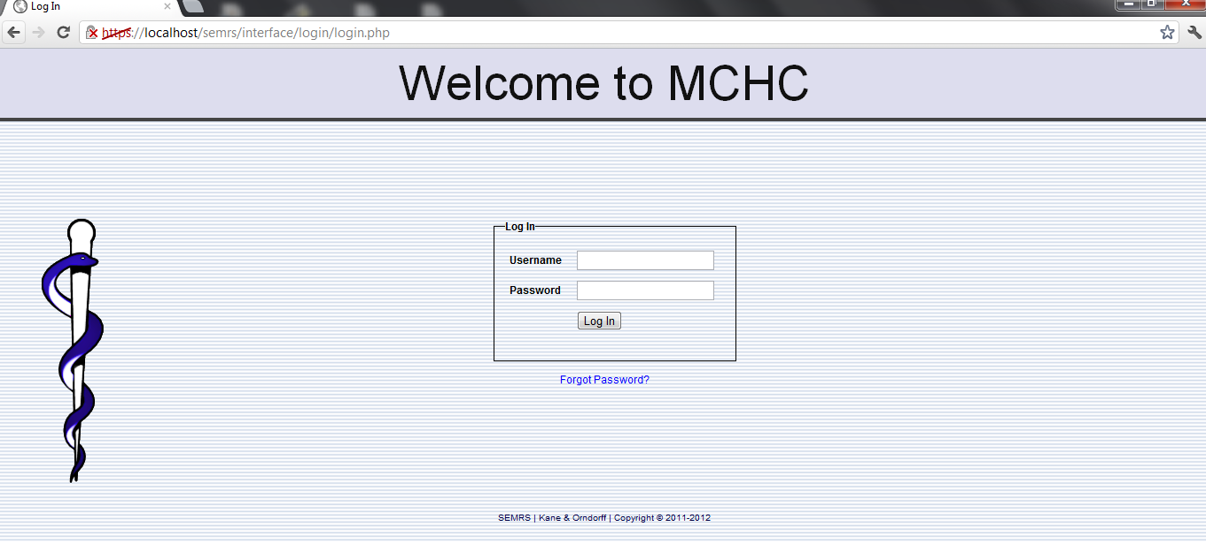

## Logging In

The login screen contains two input boxes: 'Username' and 'Password'. The first time you log in to a new installation of SEMRS you will need to log in as "admin" with a password of "pass". Your administrator may provide you with your own username and password. (Note that the SEMRS login is case-sensitive.)

You will also be presented with a drop-down list of possible languages in which you can view SEMRS. The default language (English) should already be selected.

Once you have entered the correct username and password, simply click the 'Login' button or press 'Enter'.

## Changing Passwords

If this is your first time logging in to SEMRS it is recommended that you change your password to something more secure. To do this select the 'Account Management' tab from the navigation list on the left.

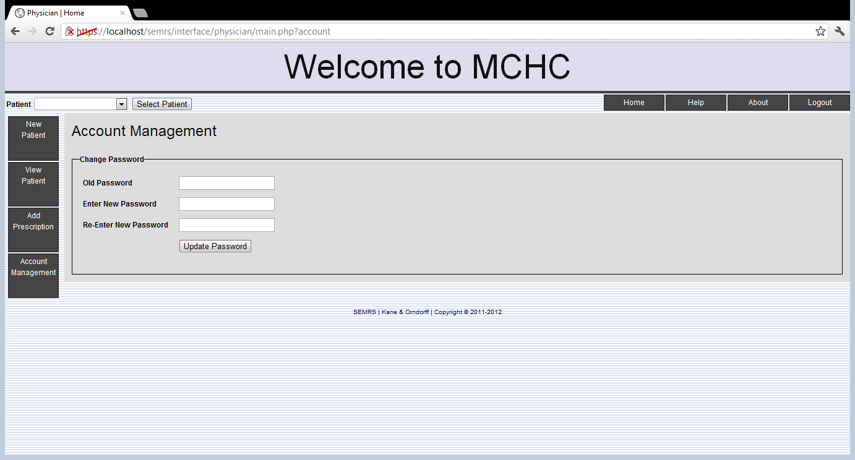

This will bring up the “Change Password” screen. Enter your new password into the two input boxes; make sure you type the same thing into each box. And keep in mind SEMRS's username and passwords are case sensitive.

Once you've done this, click the 'Update Password’ button. You will then be required to login again with your new password.

# Main Screen & Navigation

After successfully logging in, you will be brought to the main screen of SEMRS. Depending on the user account type, the main screen will differ depending on if the user has administrator access, physician access, receptionist access, or pharmacist access.

## Physician

The Physician’s Home Screen allows for four basic functions: adding a new patient, viewing an existing patient, adding a prescription, and account management (for changing of passwords). Access to these four functions is conveniently located on the left hand side.

Patients can also be searched for using the drop down search bar at the top of the screen right next to the ‘select patient’ button.

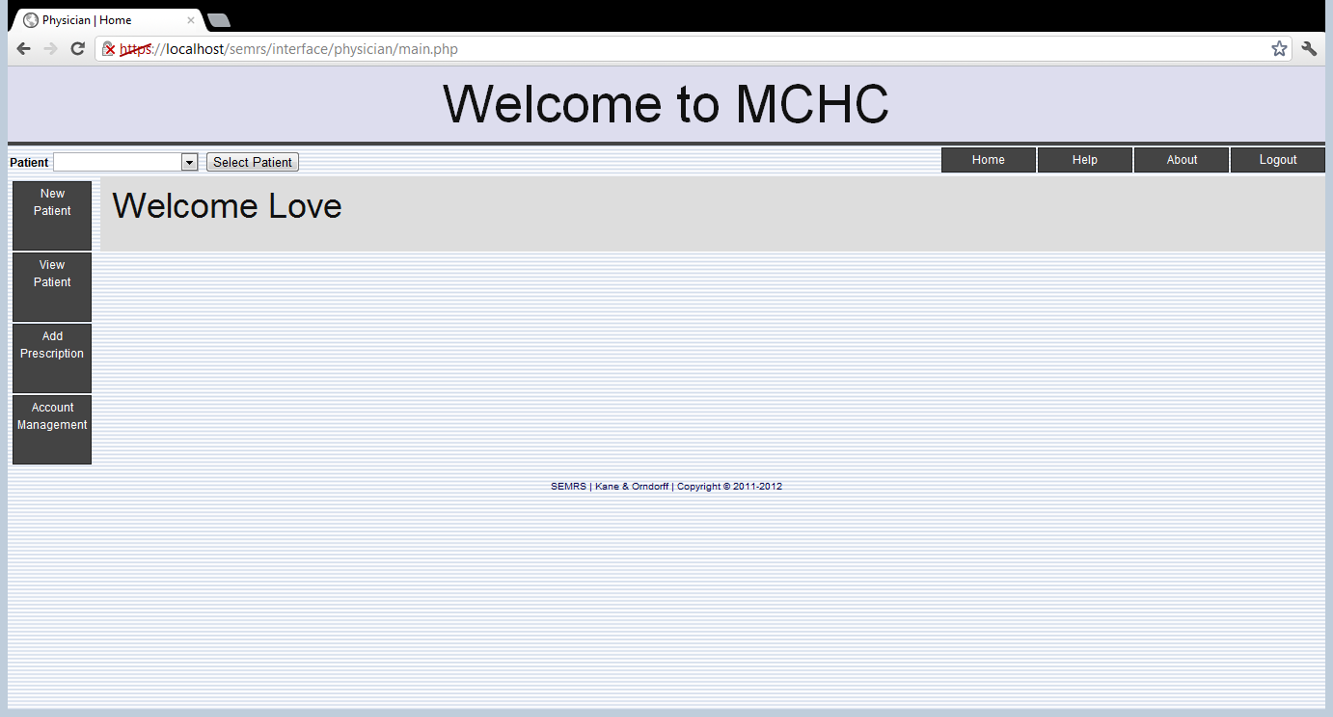

## Receptionist

The home screen for the receptionist allows for adding patients, updating patient information, adding visit information, as well as updating visit information. To accomplish all these tasks, just click the buttons on the left hand side of the screen.

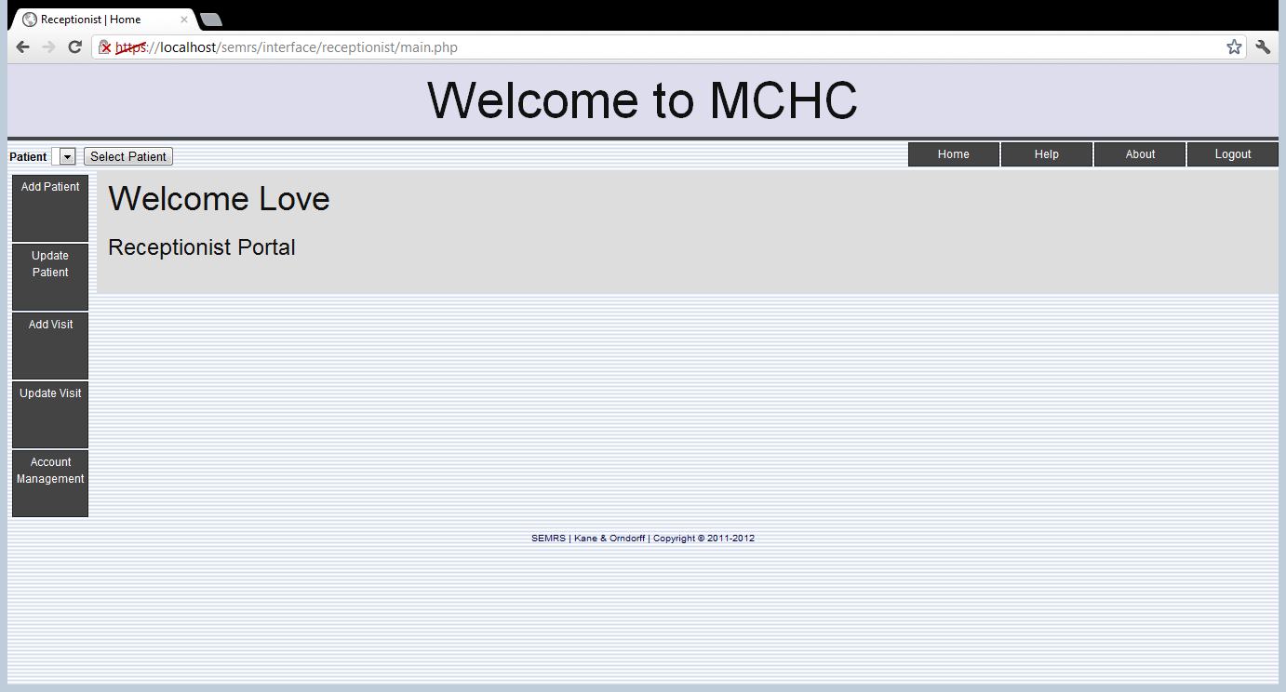

Information that can be entered for a patient includes general information, contact information, as well as primary and secondary insurance information (if applicable).

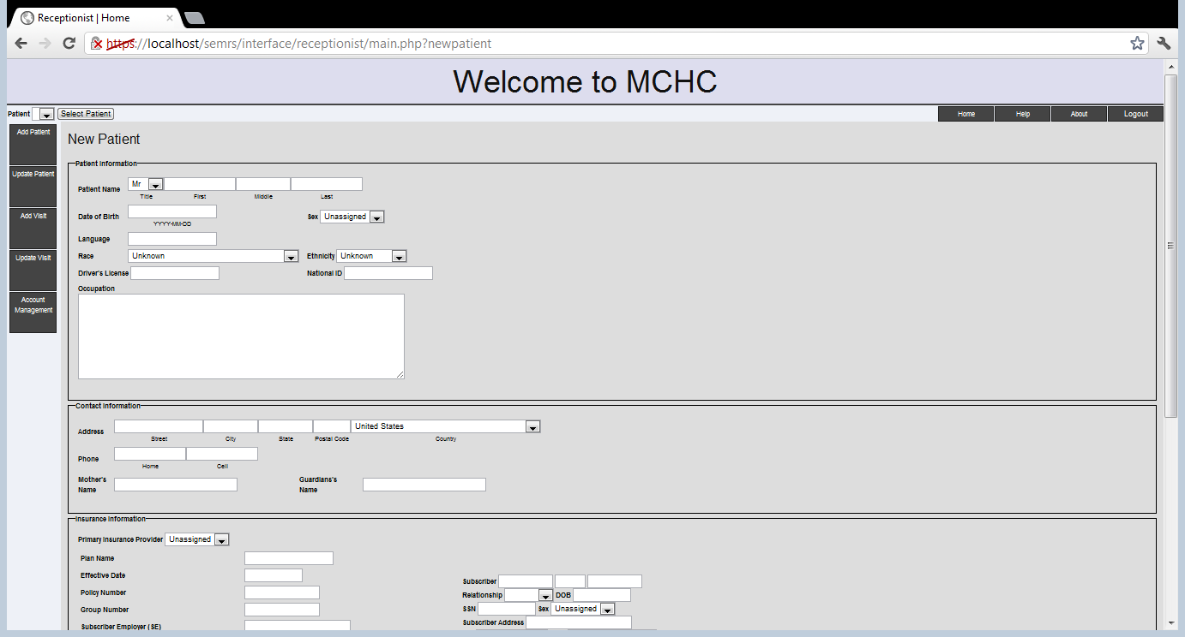

## Adding Visit Information

Receptionists have the ability to add visit information, so Physicians are able to view a patient’s appointments so the doctor knows exactly when a patient has been seen in the clinic, and when they will be back for future visits. In order for a receptionist to add visit information, just click “add visit” on the left hand side. This will take you to the add visit form. The add visit form is where appointment information is submitted, including what day and what time a patient plans on coming to the clinic.

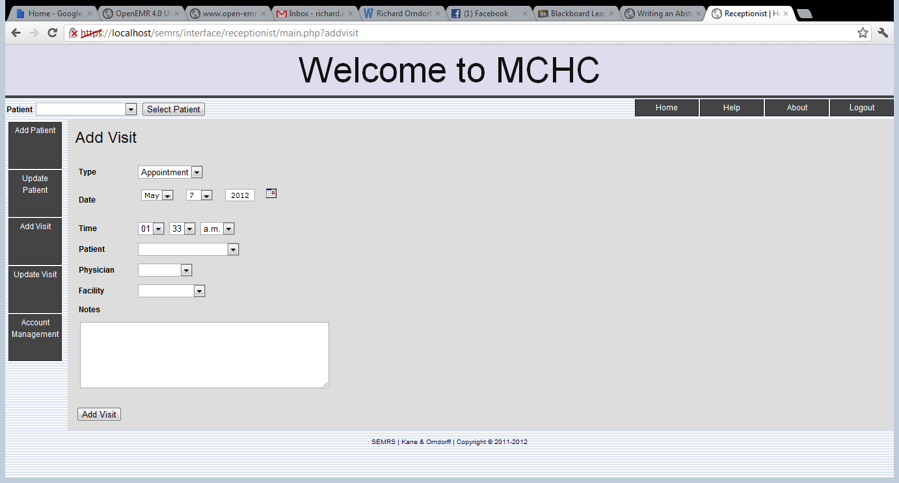

After a visit is entered, Physicians have the ability to see appointment information under the patient profile page. (See page 11)

## Pharmacist

The pharmacist portal allows for the filling of prescriptions. In order for a pharmacist to fill a prescription in the system, just click the “Fill Prescription” button on the left hand side after selecting a patient from the drop down list and clicking “select patient”. Then, just fill in the required information on the next page in order to store prescription information. 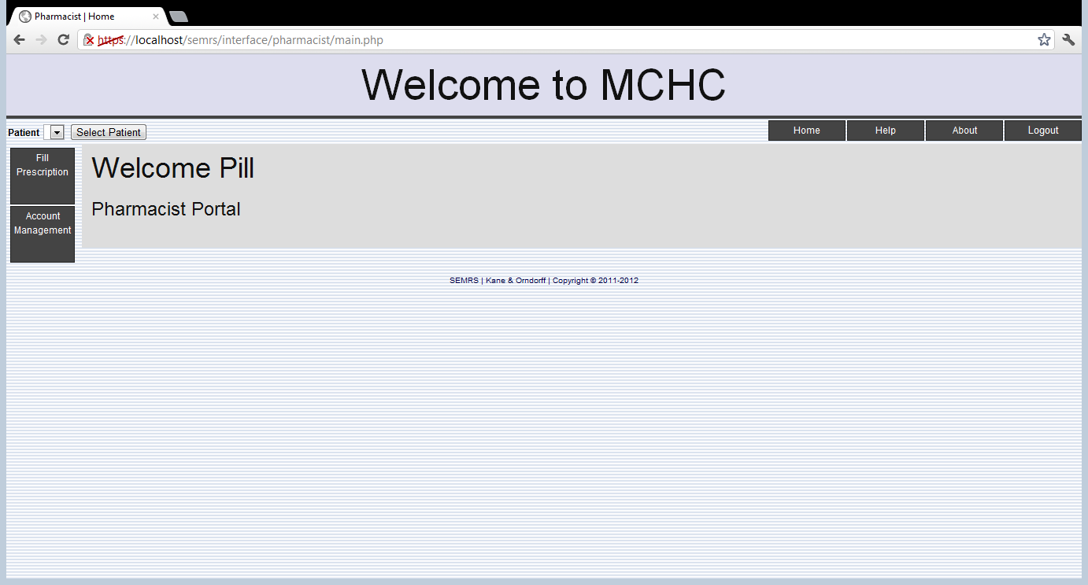

# Adding a New Patient

Access for adding a new patient is granted to physicians and receptionists only. In order to do this, on either the physician or receptionist home page, just click the “add patient” button, which will then pull up the form to enter patient general information, contact information, as well as primary and secondary insurance information (if applicable).

# Viewing a Patient

Physicians and receptionists are able to view patient’s records as needed. In order to do this, the user can click the “View Patient” button located on the left hand side directly under the “Add User” button. Users can search for patients’ two ways; either by their birth year or last name. After searching, just click the select patient button directly next to the drop down list. Once a patient is selected, click the “View Patient” button, and it will take you to the patient information screen, where a user can then upload an image for a patient. This screen also displays appointments, prescriptions, messages about the patient, as well as user access history. In order to access any of this information, just click on the appropriate tab to display the respective information.

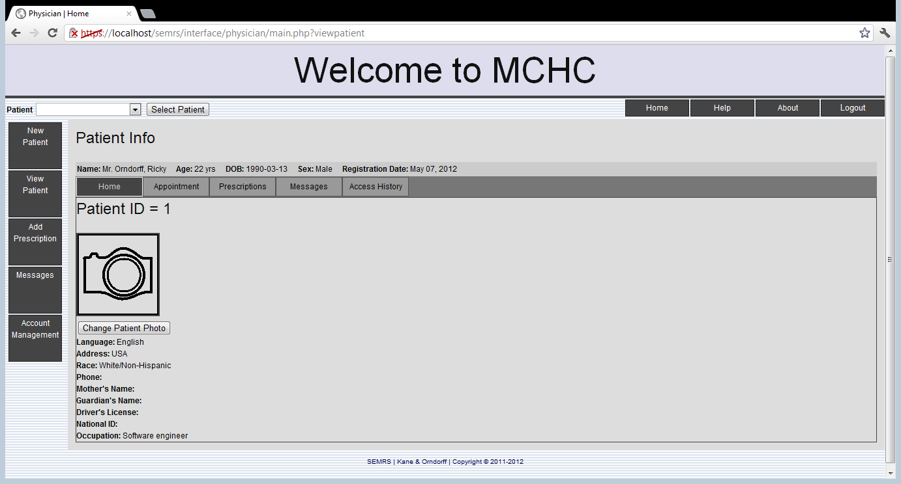

## Changing a Patient’s Photo

In order to change a patient’s photo, click on the “Change Patient Photo” button directly below the image box. You can then browse your computer for an image by pressing the “Choose File Button”. Once an image is selected, click “submit” and the new image will appear.

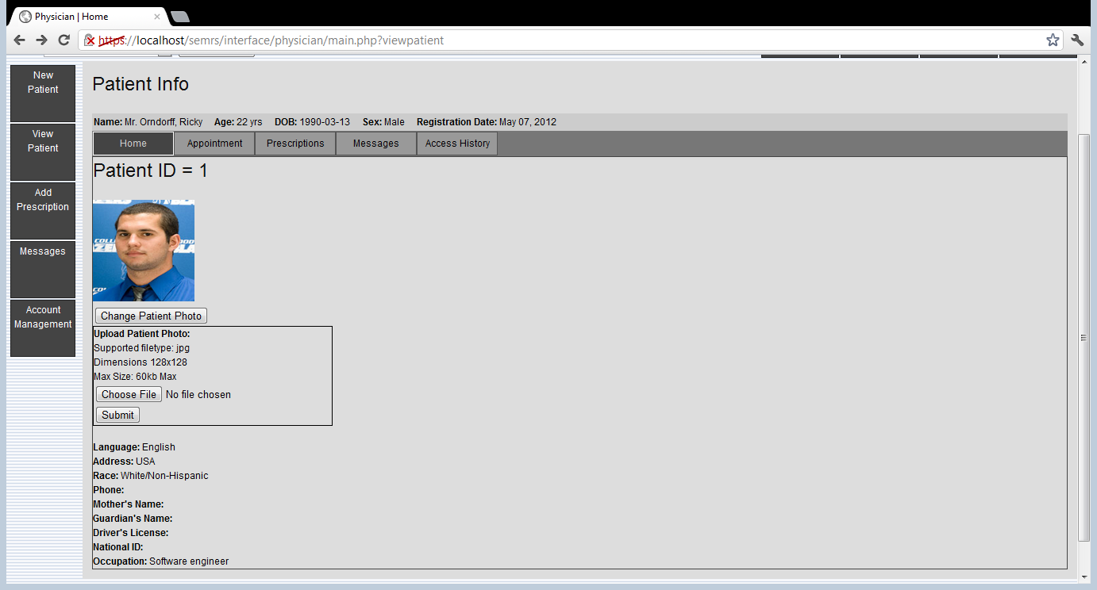

## Viewing Appointments

After a receptionist enters appointment information, Physicians can access a patient’s appointment schedule, including past and present appointments. In order to access this list, just click the “Appointment” tab next to the “Home” tab.

